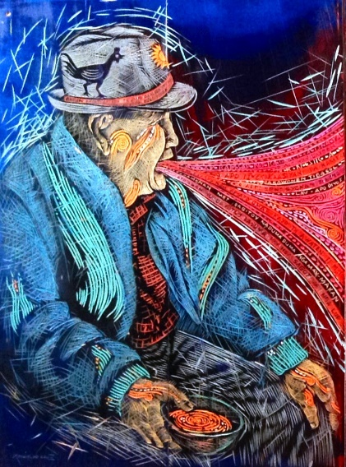 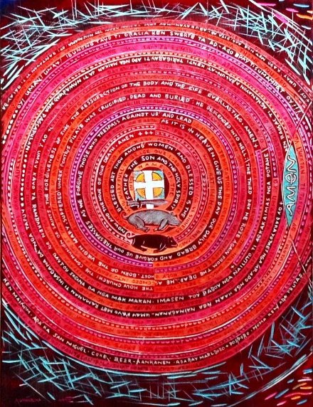 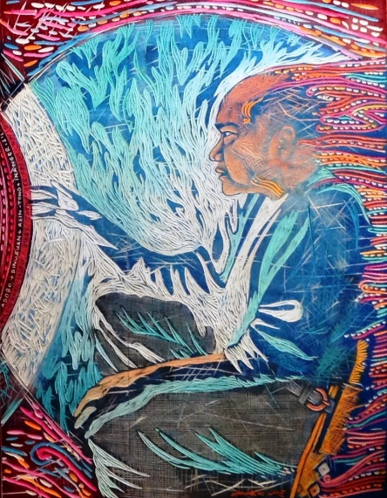

*Leonard Aguinaldo*

“Atang”, 2014.

Mixed media (including rubber) on board.

24” X 72”

“Atang” is Tagalog for “Imposition” or “Subjection” – no doubt a lot of both